Togiak 2019 ASL sampling plan options for various levels of funding

## Current funding: $0 of additional industry funding

Sampling sufficient to allow daily weight distributions from purse seine samples throughout the spawning season for in-season management and age composition of the purse seine fishery, gillnet fishery, and partial spawning population age composition (same as past years).

* Inseason sample 250 purse seine fish a day for weight, length, sex, maturity stage, and scale pluck and, after the season, age 1,000 (subsampled) purse seine scales.
* This revised sampling plan should cut down inseason sampling of purse seine landings by approximately 50% and should cut down postseason aging of purse seine scales by about 80%.
* Inseason sample 100 gillnet fish every 3 days for weight, length, sex, maturity stage, and scale pluck and, after the season, age all scales collected.
* This should keep in-season sampling and post-season aging of gillnet fish approximately the same as the average of the last two years or slightly less.

## Level 1: $70k of additional industry funding:

In addition to the above sampling in ‘Current Funding,’

Sampling sufficient to allow daily weight distributions from purse seine samples throughout the spawning season for in-season management and age composition of the purse seine fishery, gillnet fishery, and partial spawning population age composition (including 14 days of post-fishery seine sampling).

* + Charter a purse seine vessel starting the day after the purse seine season ends and lasting 14 days (the 80th percentile of number of days from when the purse seine fishery closes and the last observed spawn occurs).
  + **Expected cost to industry 14 days * $5k per day = $70k**
  + This will require 14 days sea-duty for the sampler on the charter.
  + Sample 250 fish/day during the charter for weight, length, sex, maturity stage, and scale pluck. After the season, age 500 (subsampled) purse seine scales.
    - This should keep inseason (fishery plus post-fishery charter) sampling of purse seine fish approximately the same as the average of the last two years.
    - This should cut down on post-season aging of purse seine samples by approximately 75%.

## Level 2 of additional industry funding:

In addition to the above sampling in ‘Current Funding,’

Sampling sufficient to allow daily weight distributions from purse seine samples throughout the spawning season for in-season management and age composition of the purse seine fishery, gillnet fishery, and partial spawning population age composition (including 24 days of post-fishery seine sampling).

* + Charter a purse seine vessel starting the day after the purse seine season ends and lasting for 24 days (the 90th percentile of number of days from when the purse seine fishery closes and the last observed spawn occurs).
  + **Expected cost to industry 24 days * $5k per day = $120k**
  + Sample 250 fish/day during the charter for weight, length, sex, maturity stage, and scale pluck. After the season, age 500 (subsampled) purse seine scales.
  + Level 2 will increase the number of fish sampled in-season for weight, length, sex, maturity and scale pluck by about 50% (estimated 9,500 fish) compared to the last two years, and will require 24 days of seaduty for the sampler on the charter.
  + Level 2 should cut down on postseason aging by approximately 70% (2000 scales for purse seine and gillnet fishery and charter sampling in 2019, compared with 6300 average scales for 2017 and 2018).

## Level 3 of additional industry funding:

At this level of funding, sampling for inseason management and for population age structure, length, weight, sex, and maturity stage would be done on the charter vessel. Sampling of the purse seine harvest and gillnet harvest would be done on shore.

Sampling on the charter vessel would be sufficient to allow daily weight distributions from samples throughout the spawning season for in-season management and age composition and nearly-complete spawning population age composition (including 4 days pre-fishery, 12 days during the purse seine fishery, 24 days of post-fishery seine sampling). Not only would this cover the spawning season temporally, but would cover the prefishery biomass and would cover the spawning grounds spatially during the fishery instead of sampling from the commercial harvest.

* + Charter a purse seine vessel starting the day first biomass is observed and lasting 40 days.
  + **Expected cost to industry 40 days * $5k per day = $200k**
  + Sample 250 fish per day on the purse seine charter (pre-fishery, during the fishery, after the fishery) for weight, length, sex, maturity stage, and scale pluck. After the season, age (subsample) 1000 scales from scales collected during the peak season, and 500 scales from among the scales collected during the post-peak season.
  + Inseason sample 100 purse seine fishery fish every other day for weight, length, sex, maturity stage, and scale pluck and, after the season, age all the scales collected.
  + Inseason sample 100 gillnet fish every 3 days for weight, length, sex, maturity stage, and scale pluck and, after the season, age all scales collected.
  + Level 3 will require approximately twice the number of fish sampled in-season for weight, length, sex, maturity and scale pluck (estimated 11,100 fish), compared to the last two years, but will require 60% fewer purse seine scales to age post-season (estimated 2,600 scales).

# Appendix 1: Definitions

In-season: Period in which the spawning population is present. Includes the pre-fishery season, peak season, and post-peak season

Pre-fishery: Period started at first observed biomass and ending when the fishery starts.

Post-fishery: Period after which the purse seine and/or gillnet fishery ends.

Post-season: After all in-season sampling has commenced. When aging and stock assessment occur.

# Appendix 2: Resources

* It is assumed that we have the same ADF&G staff and resources to sample and age as the last two years. The only cases where additional sampling is proposed are shown in red font.
  + The last two years we have sampled enough purse seine fish for weight, length, sex, maturity stage, and scale-pluck in-season to result in approximately 5,700 readable purse seine scales aged post-season (Appendix 6; 4,010 fish were sampled in 2017 and 7,380 in 2018, for an average of 5,695 fish).
  + The last two years we have sampled enough gillnet fish for weight, length, sex, maturity stage, and scale-pluck in-season to result in 600 readable scales aged post-season (Appendix 6; 980 fish were sampled in 2017 and 220 in 2018, for an average of 600 fish).
* It is assumed that we may have additional funding for the collection (charter vessel) of samples, but that we will not have additional staff and resources to sample and age additional fish collected with funds from industry.

# Appendix 3: Objectives of Togiak ASL sampling

## In-season management

* Estimate weight frequency of purse seine harvest every day in the fishing season to evaluate the approximate size composition of herring on the Togiak spawning grounds, in order to achieve the following objectives of the 5 AAC 27.865 Bristol Bay Herring Management Plan:

(b) To ensure that no gear group is totally disadvantaged, the Board of Fisheries directs the department to take the following actions given the specified circumstances:

(6) if a manageable separation of the year classes occurs, an exploitation rate of up to 20 percent may be allowed on the younger age herring (four years or less), and no fishery may be considered if this recruit population is less than 20,000 short tons;.

(7) late season (post-peak) herring fishery openings must be based on one or more of the following criteria: (A) a definable increase in the biomass of herring present on the fishing grounds; (B) a major shift in the age composition of the herring in a definable biomass that is large enough to allow a harvest.

## Post-season estimates for use in age-structured assessment model

* + Estimate the age composition and average weight at age of the spawning population
    - The sample size goal from the peak-season is 1000 aged fish. The sample size goal from the post-peak season is 500 aged fish. The minimum acceptable sample size goal from either the peak-season or post-season is 300 aged fish. The age composition of the spawning population is the most influential of the age compositions used in the ASA model so every effort should be made to meet the 500 aged fish goal.
  + Estimate the age composition and average weight at age of the commercial purse seine harvest
    - The sample size goal from the purse seine harvest is 500 aged fish. The minimum acceptable sample size goal from the season harvest is 300 aged fish. This is the second most influential age composition in the ASA model, so every effort should be made to sample at least 400 aged fish and, preferably, 500.
  + Estimate the age composition and average weight at age of the commercial gill net harvest
    - The sample size goal from the season harvest is 500 aged fish. The minimum acceptable sample size goal from the season harvest is 300 aged fish. This is the least influential age composition in the ASA model, so if aging time needs to be cut, this is the best place to do it. However, if less than 300 fish are able to be aged, it is worth saving resources, not aging any, and we can borrow an age composition from another year for the ASA model.

# Appendix 4: Detailed recommendations for ASL sampling under current funding and three levels of additional industry funding

## Current funding

* + Inseason sample 250 purse seine fish a day for weight, length, sex, maturity stage, and scale pluck for 9-14 days (minimum to maximum number of days of purse seine landings from 2011 to 2018; Appendix 7). If sampling more than one landing/location, divide the 250 by the number of landings/locations. This will provide a daily weight distribution for inseason management.
    - Multiple landings/locations are beneficial for representing the population, but the benefit of getting full weight distributions for each location (250 samples each) is low for inseason management and is not necessary to achieve ASA objectives.
    - This should cut down inseason sampling of purse seine landings by approximately 50% (i.e. an estimated 3000 samples for 2019 if the season extends 12 days (median number of days of purse seine landings from 2011 to 2018; Appendix 8) compared with 5700 average samples for 2017 and 2018).
  + Inseason sample 100 gillnet fish every 3 days for weight, length, sex, maturity stage, and scale pluck. This should provide 400 gillnet fish for aging with a minimum 12 days of gillnet landings, 500 gillnet fish for aging with a median season length of 15 days (median number of days of gillnet landings from 2011 to 2018; Appendix 8), and 600 gillnet fish for a near-maximum historical days of gillnet landings of 18 days. The sample sizes noted above are for readable scales (i.e. ageable fish), so if additional samples need to be taken to guarantee ages, these numbers will need to be adjusted. This will provide a sufficient sample size to estimate a single age composition for the gillnet season harvest.
    - This should keep inseason sampling of gillnet fish approximately the same as the average of the last two years or slightly less.
  + Post-season subsample 1000 purse seine scales for aging from among the 2250-3500 collected inseason from the purse seine fishery. These samples will represent both the spawning population and the purse seine fishery. Sample evenly among days, assuming that sampling inseason was conducted randomly and daily, and systematically sample within each day’s sample (e.g. sample every ith fish until the sample size goal is met).
    - This should cut down postseason aging by about 80% (1000 purse seine scales for 2019 compared with 5700 average scales for 2017 and 2018)
  + Post-season sample all gillnet scales for aging.
    - This should keep post-season aging of gillnet fish approximately the same as the past two years, or slightly less.

## Level 1 of additional industry funding

In addition to the above sampling in ‘Current Funding,’

* + Charter a purse seine vessel starting the day after the purse seine fishery season ends and lasting for 14 days (80th percentile of historical number of days between first harvest and last spawn (26 days; Appendix 9) minus median duration of the purse seine season (12 days; Appendix 8)). **Expected cost to industry 14 days * $5k per day = $70k**
    - Sample 250 fish per day (divide this among as many schools as practicable, e.g. 250 from one school, 125 from two schools, or 50 fish from five schools) during the charter for weight, length, sex, maturity stage, and scale pluck .
    - This will require 14 days sea-duty for the sampler on the charter.
    - Post-season subsample 500 scales for aging from among the 3500 collected during the charter. Sample evenly among days, assuming that sampling during the charter was conducted randomly daily, and systematically sample within each day’s sample (e.g. sample every ith fish until the sample size goal is met).
    - This should keep sampling during the purse seine fishery (2250-3500 fish), gillnet fishery (500), plus charter sampling (3500 fish) approximately the same as the average of the last two years.
    - This should cut down on postseason aging by approximately 75% (1500 scales for purse seine inseason and charter sampling in 2019 along with 500 scales for gillnet compared with 6300 average scales for 2017 and 2018)

## Level 2 of additional industry funding

In addition to the above sampling in ‘Current Funding,’

* + Charter a purse seine vessel starting the day after the purse seine fishery season ends and lasting for 24 days (95th percentile of historical number of days between first harvest and last spawn (36 days; Appendix 9) minus median duration of the purse seine season (12 days; Appendix 8)). **Expected cost to industry 24 days * $5k per day = $120k**
    - Sample 250 fish per day (divide this among as many schools as practicable, e.g. 250 from one school, 125 from two schools, or 50 fish from five schools) during the charter for weight, length, sex, maturity stage, and scale pluck .
    - Post-season subsample 500 scales for aging from among the 6000 collected during the charter. Sample evenly among days, assuming that sampling during the charter was conducted randomly daily, and systematically sample within each day’s sample (i.e. sample every ith fish until the sample size goal is met).
    - This should increase sampling of weight, length, sex, maturity and scale pluck by 50% (inseason sampling of 3500 fish, plus charter sampling of 6000 fish compared to the average of the last two years (6300 fish) and require 24 days seaduty for sampler on the charter.
    - This should cut down on postseason aging by approximately 70% (2000 scales for purse seine and gillnet inseason and charter sampling in 2019, compared with 6300 average scales for 2017 and 2018).

## Level 3 of additional industry funding

At this level of funding, sampling for inseason management and for population age structure, length, weight, sex, and maturity stage would be done on the charter vessel. Sampling of the purse seine harvest and gillnet harvest would be done on shore.

Sampling on the charter vessel would be sufficient to allow daily weight distributions from samples throughout the spawning season for in-season management and age composition and nearly-complete spawning population age composition (including 4 days pre-fishery, 12 days during the purse seine fishery, 24 days of post-fishery seine sampling). Not only would this cover the spawning season temporally, but would cover the prefishery biomass and would cover the spawning grounds spatially during the fishery instead of sampling from the commercial harvest.

* + Charter a purse seine vessel starting the day first biomass is observed and lasting 40 days (95th percentile of historical number of days between first observed biomass and last spawn was 41 days; Appendix 9). Charter would extend from pre-season (median of 4 days between first observed biomass and first day of fishing; Appendix 9), during the fishing season to increase the spatial coverage of sampling to better represent the spawning population (median of 12 days for purse seine season; Appendix 8) and post fishery for 24 days (95th percentile of past number of days between first harvest and last spawn minus the median duration of the purse seine season; Appendix 9). **Expected cost to industry 40 days * $5k per day = $200k**
    - Sample 250 fish per day on the charter (divide this among as many schools as practicable, e.g. 250 from one school, 125 from two schools, or 50 fish from five schools) for weight, length, sex, maturity stage, and scale pluck .
    - Inseason sample 100 purse seine fishery fish every other day for weight, length, sex, maturity stage, and scale pluck and, after the season, age all the scales collected.
    - Inseason sample 100 gillnet fish every 3 days for weight, length, sex, maturity stage, and scale pluck and, after the season, age all scales collected.
    - Post-season subsample 1000 purse seine scales from among the 4000 scales sampled during the preseason and peak season, and 500 scales for aging from among the 6000 collected during the post-fishery charter to represent the age composition of the population. Sample evenly among days, assuming that sampling during the preseason, peak season, and charter was conducted randomly daily, and sample systematically within each day’s sample (e.g. sample every ith fish until the sample size goal is met).
    - Level 3 should approximately double sampling of weight, length, sex, maturity and scale pluck (preseason charter sampling of 1000 fish, inseason charter sampling of 2250-3500 fish, post-fishery charter sampling of 6000 fish, purse seine fishery sampling of 600 fish, and gillnet fishery sampling of 500 fish for a total of 11,100 fish, compared to the average of the last two years (5700 fish).
    - Level 3 will require 40 days seaduty for sampler on the charter, and will require separate sampler on land to do the purse seine and gillnet fishery sampling.
    - Level 3 should cut down on postseason aging by approximately 60% (estimated 2,600 scales for 2019, compared with 6300 average scales for 2017 and 2018).

# Appendix 5: Assumptions, guiding principles, and sample size determination

* The size/age of fish on the spawning grounds generally starts with large/old fish early in the season and moves to small/young fish late in the season.
* A sample size of 250 fish should provide a weight frequency distribution that we can be 90% confident will be within 10% of the true weight frequency of the landing from which it was sampled (see simulation in Appendix 7 which is based on the methods of Miranda (2007) and the assumption that the most complicated weight frequency distribution will be bimodal, as seen in 2018).
* The sample size goal for estimating age composition is 510 aged fish. A sample size of 500 (rounded to 500) should provide an estimated age composition for which the estimated proportion of each age class is within 5% of the true age composition of the landings/population from which it was sampled with at least 95% probability.
* In the case that the 500 sampling goal cannot be met, a sample size of 400 fish should provide an estimated age composition for which the estimated proportion of each age class is within 5% of the true age composition of the landings/population from which it was sampled with at least 90% probability.
* The minimum sample size for estimating age composition is 300 aged fish. Below this sample size, it is generally not worth the cost of salary to age the samples due to the low confidence of the resulting age composition. A sample size of 300 should provide an estimated age composition for which the estimated proportion of each age class is within 5% of the true age composition of the landings/population from which it was sampled with at least 80% probability.
* The sample size to estimate weight at age is generally much lower than that to estimate age composition, and the impact of weight at age in the ASA model is less than that of age composition, so the sample size recommendations are based on those needed to estimate age composition with the expectation that for most/all age classes, the precision of the weight at age estimates will be sufficient.
* GREG – we should talk about the best way of determining peak season, vs post-peak season for the purpose of subsampling scales post-season. In the above write-up, I assumed that the fishery covered the peak season and charter sampling after the fishery was post-peak season.
* For the purposes of estimating mature biomass from aerial surveys, the herring are assumed to enter the spawning grounds (visible to aerial surveys) and continue to gather until peak biomass is observed, after which fish leave the spawning grounds. A second wave of herring are assumed to enter the spawning grounds and gather until the post-peak biomass is observed, after which the second wave of herring leave the spawning grounds. While this is undoubtedly a large simplification of the spawning aggregation process, it is likely a conservative one for estimating biomass. Since there is not a way to estimate an unbiased survey estimate, a conservative one is chosen.

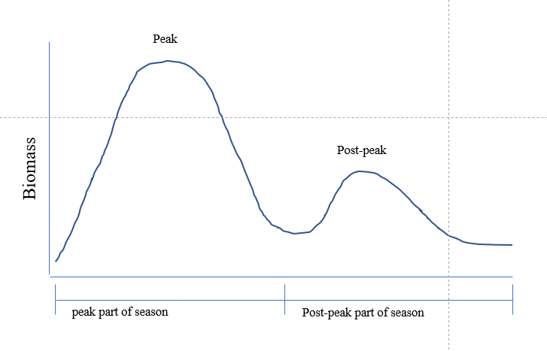

* If the spawning aggregation process described in the bullet above holds and we assume that the peak biomass is twice as large as the post-peak biomass (see Appendix 10; peak biomass ranges from equal to post peak biomass to four times greater than post-peak biomass for the last four years (2012-2015) of aerial surveys used in the ASA model), sampling of age composition should be representative of the population if 1000 fish are sampled/aged from the day of peak biomass and if another 500 fish are sampled from the day of post-peak biomass. However, if our simplified spawning aggregation process does not hold and herring are coming onto the spawning grounds and leaving in and around the peak and post-peak, we risk not sampling a majority of the herring population. So we recommend sampling evenly among days in the peak part of the season and subsampling after the season for 1000 scales. We recommend sampling evenly among days in the post-peak part of the season for 500 scales. If we do this and the simple spawning aggregation process actually does hold, then hopefully the number of times that we sample the group of fish that arrives early and leaves right after the peak (our samples on the days leading up to the peak), will hopefully average out with the number of times that we sample the fish arriving right at the peak and leaving numerous days after the peak (our samples on the days after the peak). The same concept would hold for our sampling of the aggregation of fish leading up to and away from the post-peak.
* Over the last 8 years, the purse seine fishery has lasted a minimum of 9 days, a median of 12 days, and a maximum of 14 days (Appendix 8).
* Over the last 8 years, the gillnet fishery has lasted a minimum of 12 days, a median of 15 days, and a maximum of 20 days (Appendix 8).
* Between 1977 and 2015 (39 years) the initial harvest has occurred 1 to 12 days (median 4 days) after the first sighting of biomass (Appendix 9)
* Between 1977 and 2015 (39 years) the number of days between first harvest and last observed spawn ranged from 3 to 49 days (median 16 days, 95th percentile 36 days) (Appendix 9).
* Between 1977 and 2015 (39 years) the number of days between the first sighting of biomass and last observed spawn ranged from 6 to 52 days (median 22 days, 95th percentile 41 days) (Appendix 9).

# Appendix 6: Age composition samples by year, fishery and gear type



# Appendix 7: Sample size needed to approximate weight-frequency distributions of Togiak herring

Jane Sullivan

February 2019

# 

# Background

The objective of this analysis is to determine how many samples are needed in order to approximate the underlying weight-frequency distribution of a population. The managers use this daily distribution of weights to decide when to close the fishery.

# Methods

We used 2018 weight data (g) collected across the entire fishery season. Exploratory analysis showed two samples with weights of 0 grams. These were assumed to be N/A values, and were removed from the remainder of the analysis.

A plot of the cleaned dataset is shown below:

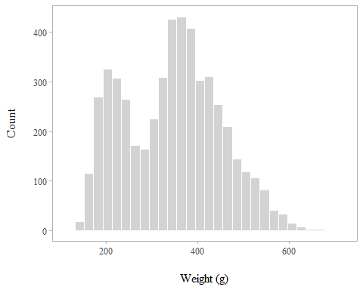

The data show a bimodal distribution, with modes at rougly 200 and 375 g. We were interested in using a bimodal distribution to set sampling goals, because it is likely the most complex distribution that biologists will encounter in-season.

We defined the reference population distribution by resampling the original data 10,000 times with replacement. We used three performance metrics to set sampling goals:

1. mean weight,
2. 25-gram bins (which we call our fine-scale resolution), and
3. 50-gram bins (our coarse resolution).

Plots of the reference population under the two binning schemes are shown below:

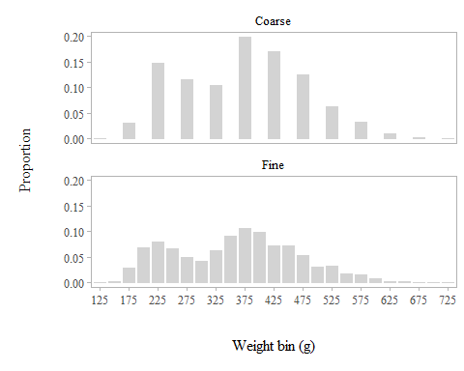

Following Miranda (2007), we took random samples without replacement of 12 sample sizes (*n*), where *n* included 25, 50, 100, 200, 300, 400, 500, 600, 700, 800, 900, and 1,000. We took each of these sample sizes 1,000 times without replacement from the reference population, and the results were compared with those of the reference population.

Each of the 12 sets of 1,000 samples were evaluated using the 3 performance metrics stated above. For mean weight, equivalence to the reference population was assessed by computing the fraction of the 1,000 estimates that fell within 10% (5% on either side) of the reference weight. For the 25- and 50-gram weight-frequency distributions, equivalence was assessed by computing the fraction of the 1,000 weight-frequency distributions that differed by 10% or less from the reference weight-frequency distribution, as measured with Renkonen’s percentage similarity index ($PS$) (Krebs 1999, Wolda 1979), where

$$PS=\sum_{i=1}{min}(p_{1,i},p_{2,i)}),$$

where $p_{1,i}$ is the proportion of the $i$ th bin in the reference population and $p_{2,i}$ is the proportion of the $i$ th bin in the sample.

# Results

The figure below shows the probability of estimating the weight-frequency within 10% of the true value based on the chosen performance metrics.

The ability to estimate the mean of the distribution requires the smallest sample size. It requires additional samples in order to approximate the distribution using a coarse resolution binning approach of 50-g bins, and even more to approximate the fine scale resolution bins.

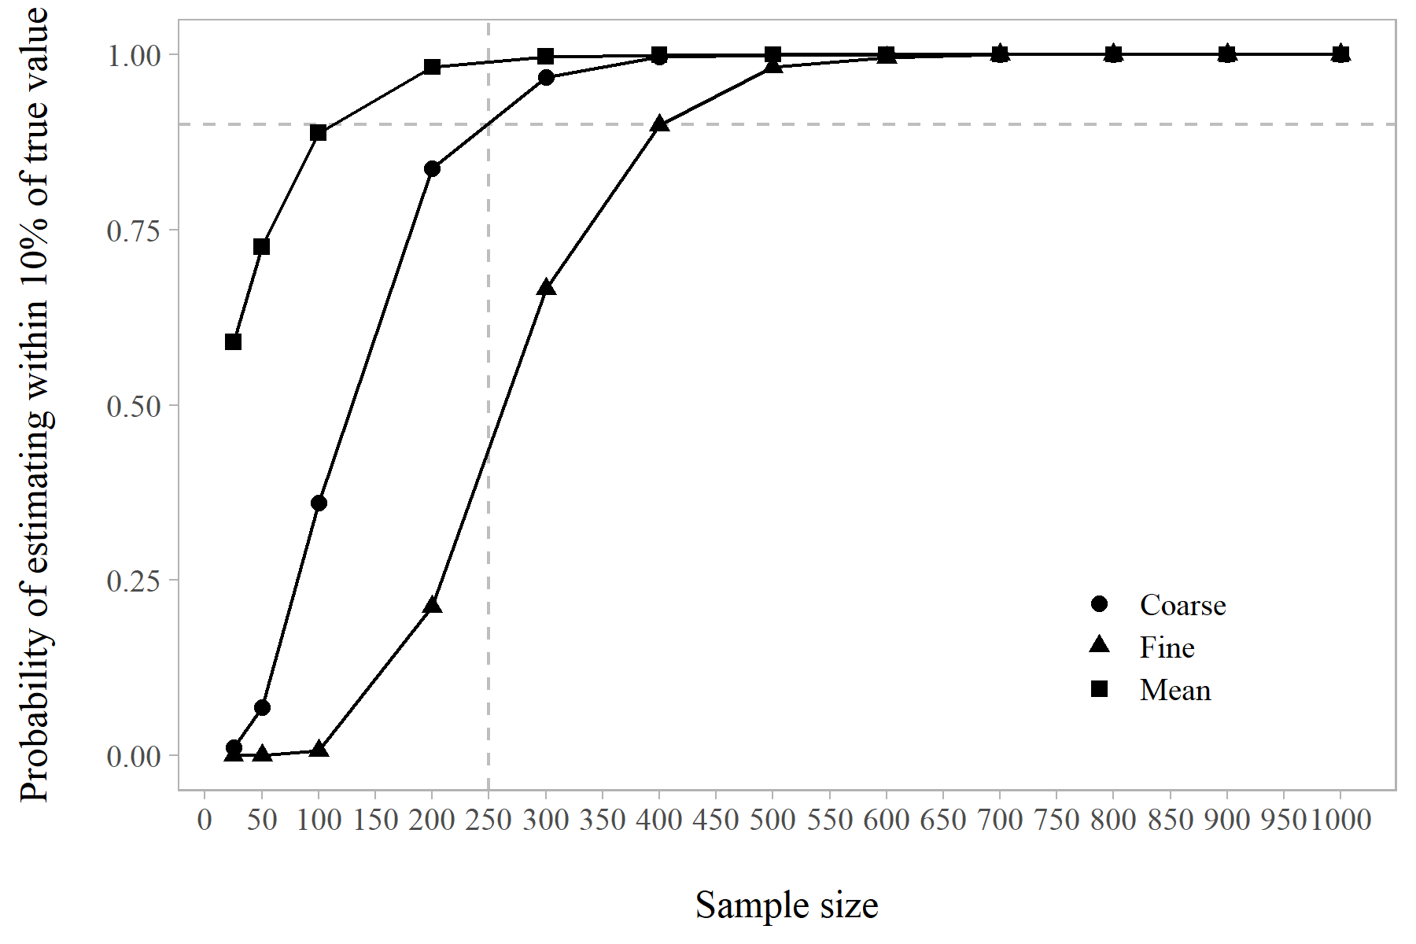

# Recommendation/Discussion

Based on this analysis, a sample size of 300 is needed in order to approximate the weight-frequency distribution 95% of the time using a coarse resolution binning of 50-g. As shown in grey dashed lines in the figure above, a sample size of 250 will result in an approximately 90% probability of estimating the true value within 10% using 50-g bins. The latter is likely sufficient to provide reasonable estimates for in-season management.

Although reducing bin size resolution increases the probability of approximating the distribution under smaller sample sizes, we do not recommend reducing the resolution below 50-g because it could mask modes in the distribution.

# References

Krebs, C. J. 1999. Ecological methodology, 2nd edition. Addison-Welsey Educational Publishers, Menlo Park, California.

Wolda, H., 1981. Similarity indices, sample size and diversity. Oecologia, 50(3):296-302.

Miranda, L. E. 2007. Approximate sample sizes required to estimate length distributions. Transactions of the American Fisheries Society 136:409–415.

# R Session Info

## R version 3.5.1 (2018-07-02)  
## Platform: x86_64-w64-mingw32/x64 (64-bit)  
## Running under: Windows 10 x64 (build 16299)  
##   
## Matrix products: default  
##   
## locale:  
## [1] LC_COLLATE=English_United States.1252   
## [2] LC_CTYPE=English_United States.1252   
## [3] LC_MONETARY=English_United States.1252  
## [4] LC_NUMERIC=C   
## [5] LC_TIME=English_United States.1252   
##   
## attached base packages:  
## [1] stats graphics grDevices utils datasets methods base   
##   
## other attached packages:  
## [1] bindrcpp_0.2.2 knitr_1.20 forcats_0.3.0 stringr_1.3.1   
## [5] dplyr_0.7.6 purrr_0.2.5 readr_1.1.1 tidyr_0.8.1   
## [9] tibble_1.4.2 ggplot2_3.0.0 tidyverse_1.2.1  
##   
## loaded via a namespace (and not attached):  
## [1] Rcpp_0.12.17 cellranger_1.1.0 pillar_1.2.3 compiler_3.5.1   
## [5] plyr_1.8.4 bindr_0.1.1 tools_3.5.1 digest_0.6.15   
## [9] lubridate_1.7.4 jsonlite_1.5 evaluate_0.10.1 nlme_3.1-137   
## [13] gtable_0.2.0 lattice_0.20-35 pkgconfig_2.0.1 rlang_0.2.1   
## [17] psych_1.8.4 cli_1.0.0 rstudioapi_0.7 yaml_2.1.19   
## [21] parallel_3.5.1 haven_1.1.2 withr_2.1.2 xml2_1.2.0   
## [25] httr_1.3.1 hms_0.4.2 rprojroot_1.3-2 grid_3.5.1   
## [29] tidyselect_0.2.4 glue_1.2.0 R6_2.2.2 readxl_1.1.0   
## [33] foreign_0.8-70 rmarkdown_1.10 modelr_0.1.2 reshape2_1.4.3   
## [37] magrittr_1.5 backports_1.1.2 scales_0.5.0 htmltools_0.3.6   
## [41] rvest_0.3.2 assertthat_0.2.0 mnormt_1.5-5 colorspace_1.3-2  
## [45] labeling_0.3 stringi_1.1.7 lazyeval_0.2.1 munsell_0.5.0   
## [49] broom_0.4.5 crayon_1.3.4

# Appendix 8: Start and end dates of commercial landings



# Appendix 9: Dates of aerial survey biomass and sightings, and date of initial harvest



# Appendix 10: Peak biomass and date, post-peak biomass, and commercial harvest

